 The GLUE of the El Paso Scale Model Society
March 2011

Our March meeting was a good one. We had 31 members and guests at the event. Miguel Garcia visited with us and he wants to become an aircraft modeler. Welcome, Miguel. He will be our fourth member from Mexico.

Brittany Terry gave birth to Miss Jessica Terry recently in Germany. Joe and Brittany are stationed there with his Infantry unit. Congratulations to Mom and Dad. Joe also bought a new Mustang GT. Within an hour of arrival, a bird did a job on the hood. Joe cleaned it up and ditto, within the hour, same thing.

Bill Coster and Mike Boudreaux deserve our thanks. Bill took care of the Contest and Mike took the pictures for this issue as usual, which is important for the making of a good GLUE. One without pictures is just that.

This was a contest meeting and we had nine entries, which were divided into three categories. We had Automobiles, Aircraft and a Miscellaneous Category
with three entries in each, thus each entry won an award.

In the Automotive Category:
Efren Zamora took the first place medal with a 1966 GTO. Hector Gonzalez took the second place spot with a 1932, 3 window Ford Coupe. Alex Rojas took third place with a Ford F-100 pickup.

.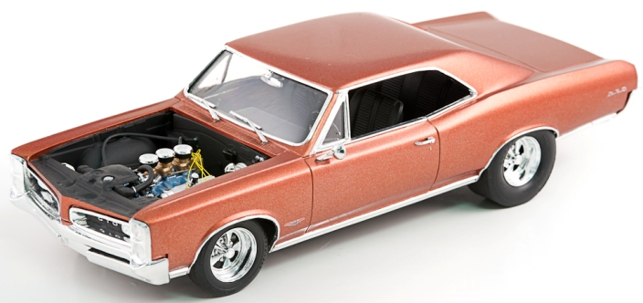
Efren’s 1966 GTO.

The GLUE of the El Paso Scale Model Society
March 2011 page 2

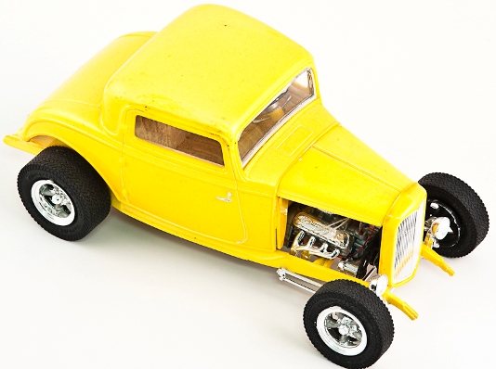

Hector’s 3 window Coupe

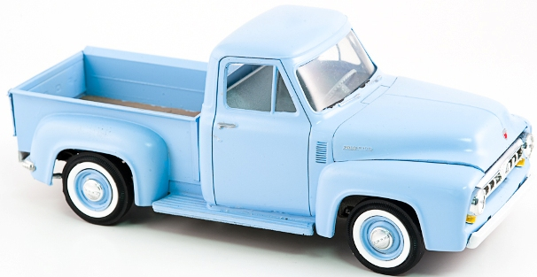
Alex’s F-100 Pickup
The GLUE of the El Paso Scale Model Society
March 2011 page 3

In the Aircraft Category:
Carlos Delgado took the top spot with an A-7. Alex Rojas won the second place medal with a Ka-50 Hokum. Steve Herren took the third award with an A-6A.

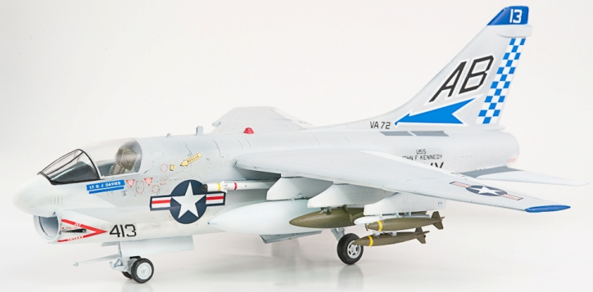

Carlos’s A-7 in 1/48th scale.

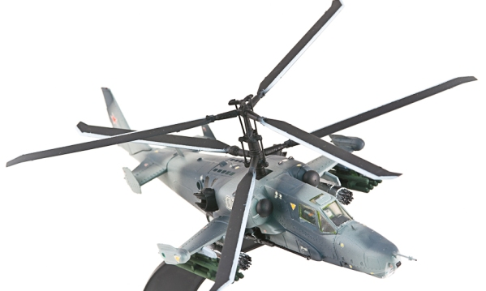
Alex’s Ha 50 Hokum

The GLUE of the El Paso Scale Model Society
March 2011 page 4

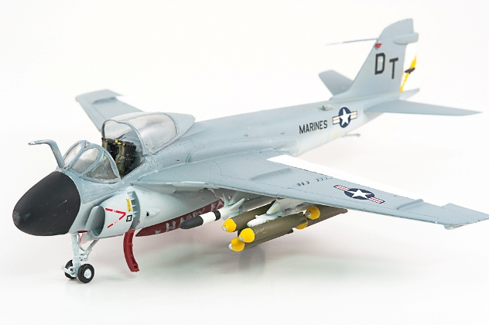

Steve’s A6

The Miscellaneous category was really that with three completely unrelated entries.
Dennis Cramer took top honors with an all wooden Ahern-Fox 1927 Fire Engine.
Bill Coster took second place with an Armored fighting Suit. Dixi Fischer took the third place slot with her German tank Commander.

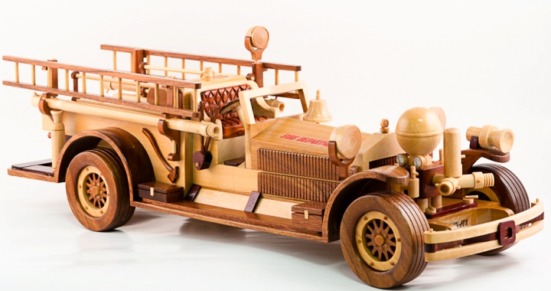

Dennis’s Scratch built from wood, the Athern-Fox Fire Truck

The GLUE of the El Paso Scale Model Society
March 2011 page 5

No pictures are available of the second and third place winners in the miscellaneous category.

On the table:

Name | Model | Scale | Kit
Jim Davis | SNJ-3 | 1/48th | Monogram | finished
 | SNJ-3 | 1/72nd | Academy | finished
Carlos Delgado | A-7 | 1/48th | Monogram | finished
Hector Gonzalez | Modified Dirt Racer | 1/24th |  | finished
 | 34 Ford Coupe | 1/24th |  | finished
Dennis Cramer | Athern-Fox Fire Engine | 1/24th | Scratch built | finished
Steve Herren | Me 109 | 1/48th |  | finished
 | A6-A | 1/72nd | Italeri | finished
Alex Rojas | Porsche 911 Carrera | 1/24th | Tamiya | finished
 | Ford F-100 Pickup | 1/24th | AMT | finished
 | Ka-50 Hokum | 1/72nd | Dragon | finished
Duane Velasquez | A2D Sky Shark | 1/72nd | Mach 2 | finished
 | XFV-1 | 1/72nd | Pegasus | finished
 | Convair | 1/72nd |  | Finished
Carl Webster | M4 composite hull | 1/35th | Dragon/DML | finished
 | M998 Hummv IED | 1/35th | Academy | finished
Roy LIngle | German Brukenleger | 1/35th | Trumpter | In the Box
Efren Zamora | 1966 GTO | 1/24th |  | finished
Dixi Fischer | German Tanker | 90mm? | Tamiya | finished

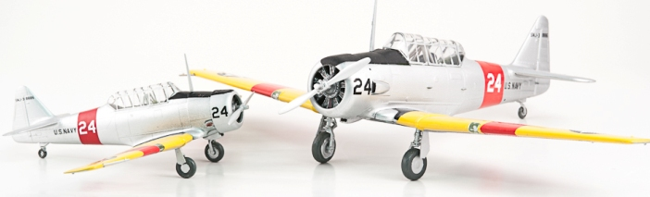

Jim Davis had another of his two of a kind. SnJ-3’s in 1/72nd scale and 1/48th scale. Jim used the
Academy and Monogram kit for this nice pair of trainers.

The GLUE of the El Paso Scale Model Society
March 2011 page 6

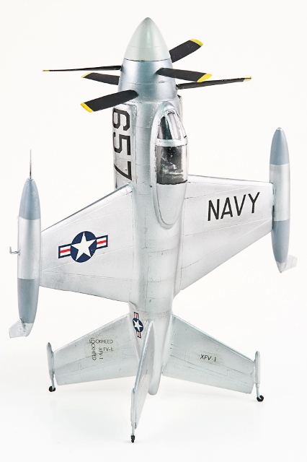

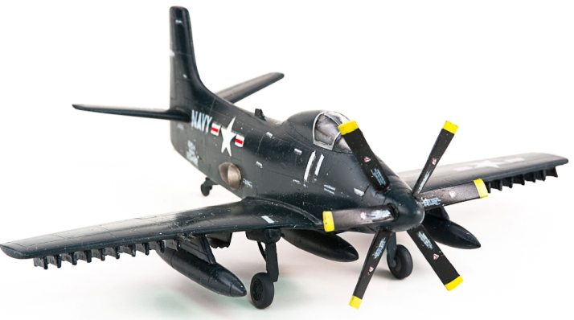

Duane Velasquez had two really nice X-planes. He used the Pagasus kit for the XV-1 and the Mach 2 kit for the A2D Sky Shark. Both are in 1/72nd scale.

The GLUE of the El Paso Scale Model Society
March 2011 page 7

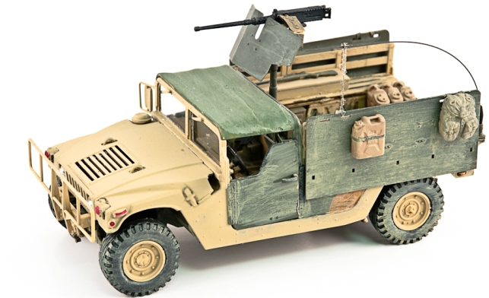

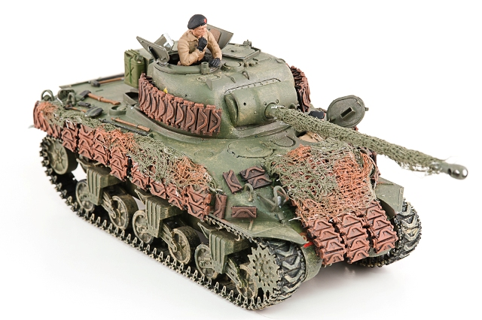

Carl Webster’s Hummv above and his M4, both in 1/35th scale.

The GLUE of the El Paso Scale Model Society
March 2011 page 8

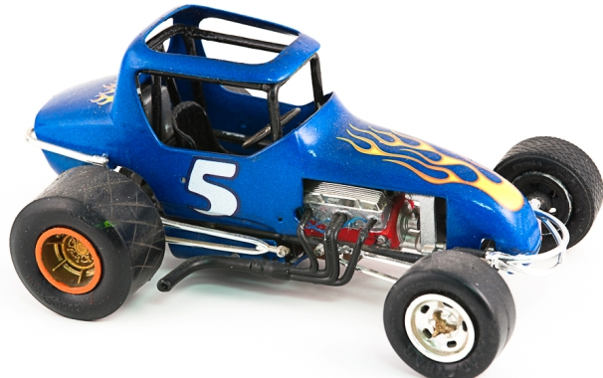

Hector Gonzalez’s Dirt racer.

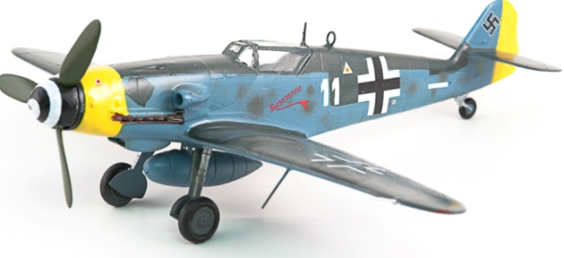

Steve Herren’s Me 109

Club officers
President…………………….John Estes IPMS 3498
Vice President……………….Bill Coster IPMS 32598
Vice President……….. Michael Drapes IPMS 29229
IPMS Chapter Contact ..Gustav Hebrok IPMS 4058
Photographer………… Mike Boudreaux IPMS

The GLUE of the El Paso Scale Model Society
March 2011 page 9

Our next meeting is on March 6 at 2:00 PM at 7000 Edgemere Boulevard.

Remaining meeting dates

April 3

May 1

June 5 Contest

July 10

August 3-6 National IPMS Convention
August 7
August 14 Bassett Place Mall

September 11 Contest

October 2

November 6
November13 Bassett Place Mall

December 4 Contest
Election of officers



